Jaladhar Patra 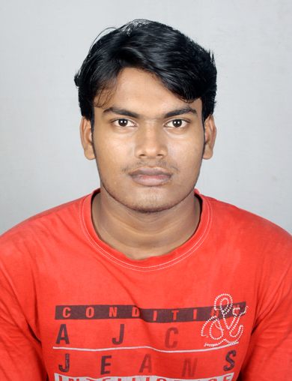
+91-9178076641
Jaladhar4u@gmail.com

Career Objective :

To achieve a position in a company where I can implement and optimize my own idea, my knowledge, show my potential and will be able to bring success for the company by utilizing my skills and knowledge .

Educational Qualification:

Qualification | Discipline/ Specialization | School/College | Board/University | Year Of Passing | % Of Marks
B-Tech | Mechanical  Engineering | Koustuv Institute of Technology,BBSR | B.P.U.T. | 2014 | 67.33 CGPA(7.2)
Diploma | Mechanical  Engineering | Koustav School of Engineering,BBSR | SCTE&VT | 2011 | 75.17
10th | - | Okara High School  Arnapal,Bhadrak | B.S.E. | 2008 | 56.37

Seminar and Project:

- Presented project on "HYDRO POWER PLANT".
- Presented seminar on seminar "DTS-I ENGINE".

Hobbies:

- Playing Cricket
- Listening Music

Co-Curricular Activities:

- Won prizes for Intra School Sports Competition

- Won Medal for Best All-Rounder in Intra-School cricket Tournament

Personal Profile:

Name : Jaladhar patra

Father’s Name : Mr. Karunakar Patra

Mother’s Name : Mrs. Laxmi Patra

Permanent address : C/o - Karunakar patra
At - Madhusudanpur
Po - Annapal
Dist - Bhadrak
Odisha-756116

Gender :Male

Marital Status :Single

Nationality : Indian

Date of Birth : 29th April 1993

Language known : English, Hindi, Odiya

Declaration:

This is hereby declared that the above mentioned details are true to the best of my knowledge and belief.

Place: Bhubaneswar Jaladhar Patra

